**Capstone Project: UC Davis Coursera**

**Analysis of Health Care Facilities within Ekiti State, Nigeria.**

**Methodology and Results of the Analysis**

***Methodology/Workflow:***

After downloading the data sets from the grid3.gov.ng, the data sets was imported into mapshapers.org to convert to shapefiles (Grid3 gives datasets as json files).

The Shapefiles are the loaded into arcGis for the analysis.

The analysis involves the following steps:

* One to One spatial join of All the health care facilities in the state to their respective Local government areas and also a One to One spatial join of All the settlements in the state to their respective Local government areas, the merge rule was set as count to get the respective counts of each settlement and health care facilities per local government.
* Two extra fields were added to include the number of health facilities and settlements in each Local government.
* Thereafter the proportion of health care facilities to settlement areas in each local government was calculated using the field calculator with the formula: health facilities/ settlements.
* The ouputs are plotted and graphs made for better visualization.

**Results:**

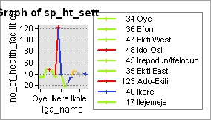

The graph above shows the number of health facilities in each L.G. The highest is 123 while the lowest is 17. This shows that more health facilities should be built in areas such as ilejemeje with only 17 health facilities.

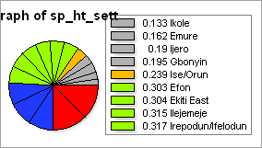

The pie chart shows the proportion of health facilities to settlements points in each local government, the pie chart shows the state does not have enough health facilities as the proportion of health facilities to settlements ranges towards 0.1333-0.317 across the Local governments.

This is a very small number.

**Conclusion:**

***There are no enough primary health care centers in the state***

